**LAB # 07**

**Task 01:** Make a flowchart of whether the student pass in a subject or not.

**Output:**

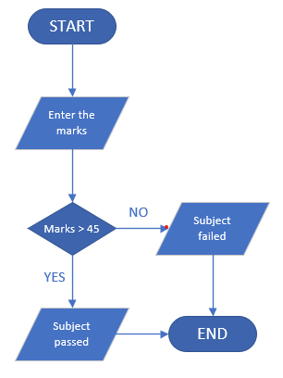

**Summary:** In this task, we created a flowchart to check if a student is pass in a subject.

**Task 02:** Make a flowchart of alarm clock process.

**Output:**

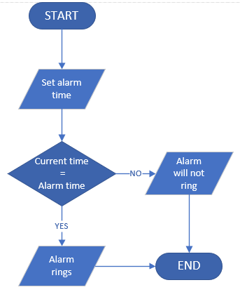

**Summary:** In this task, we created a flowchart of alarm clock process.

**Task 03:** A user enters a password and gets permission to open a lock. The password is compared with one already stored in the system. Demonstrate the process using a flowchart.

**Output:**

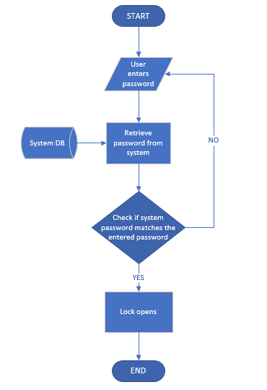

**Summary:** In this task, we made a flowchart of password check that allows user to open a lock if the user enters the correct password.

**Conclusion Of Lab:** In this lab, we learned how to make flowcharts by using Ms Visio.